Project Week 3 The logical Voltmeter
17/11/2025
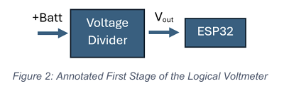
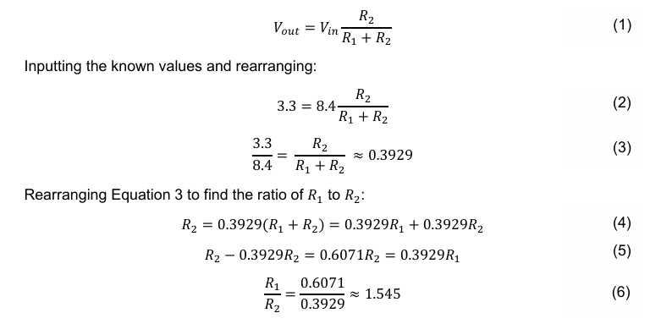
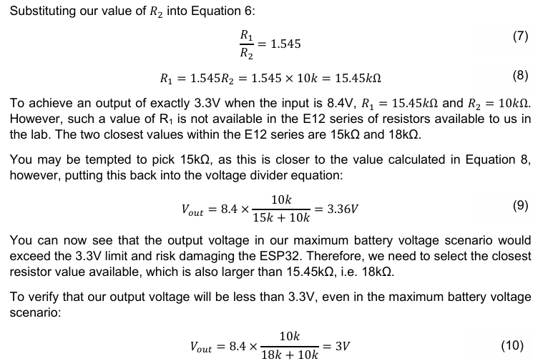
Insert picture of r26&27 and schematic from week 2

Taklk about analogue to digital conversion in technical repors
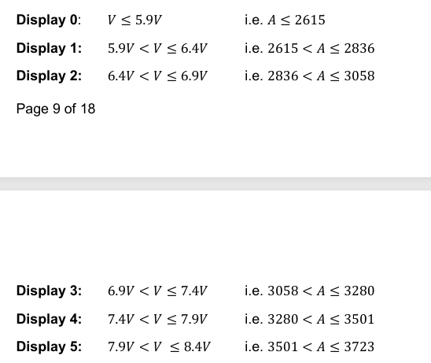
Talk about all the logic gate types here in technical report
The 7-segment display uses the common anode configuration, so the output needs to be low to light up that LED.
Below are all the numbers and the combination of letters required to output them
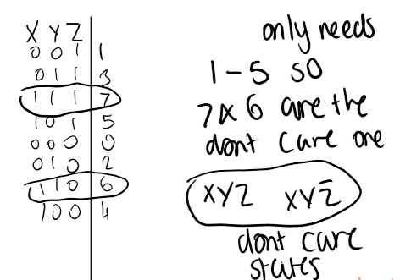
Below are all the numbers and the combination of letters required to output them
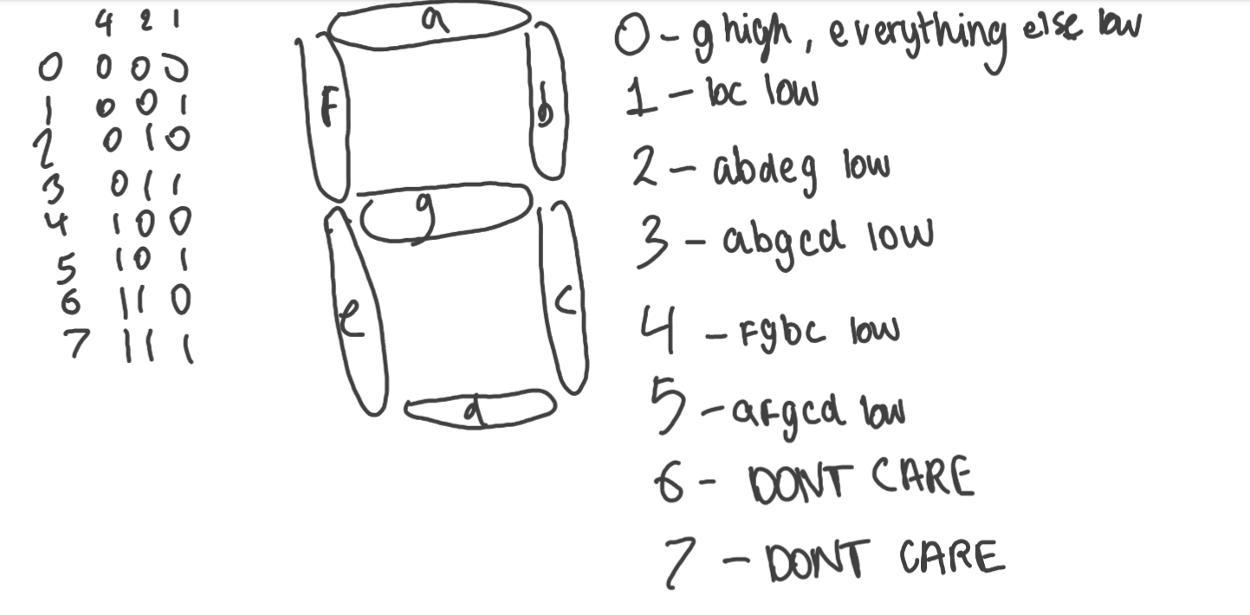

Truth Table with don’t care outputs as X
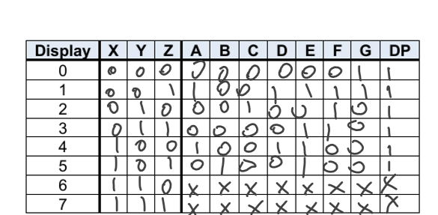

Karnaugh Map with Don’t Care states as X
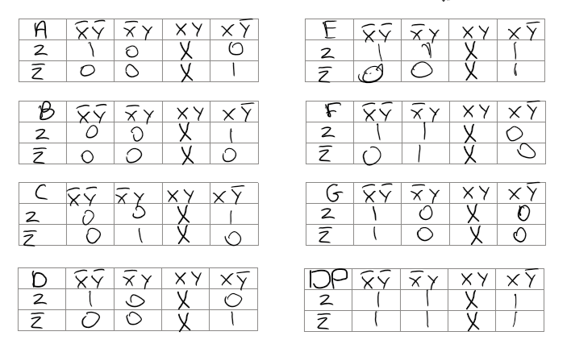
Equations from K-map without using don’t care states
Without using the don’t care states I need 12 AND gates 3 NOT Gates and 7 OR gates, this is not minimal and in the real circuit only 8 AND gates are available.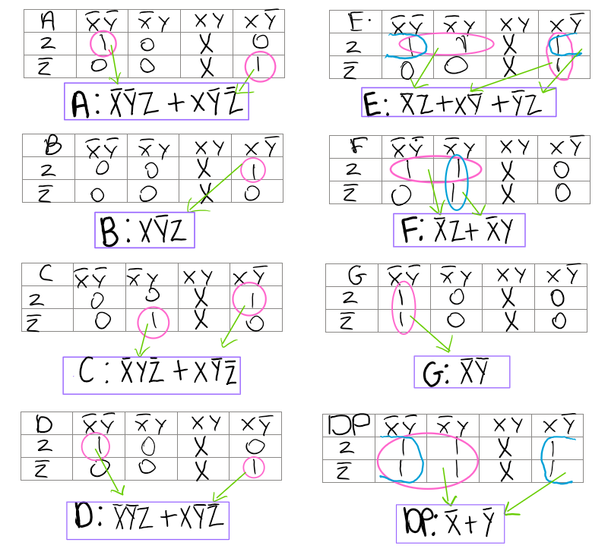

Next, I will repeat this and make use of the don’t care states so I can have minimised expressions.
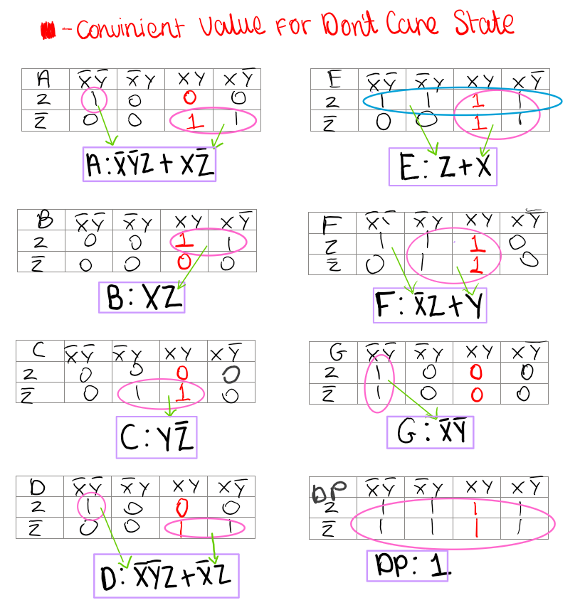
Now I only need 7 AND gates, 3 NOT gates and 4 OR gates.
Truth table using don’t care states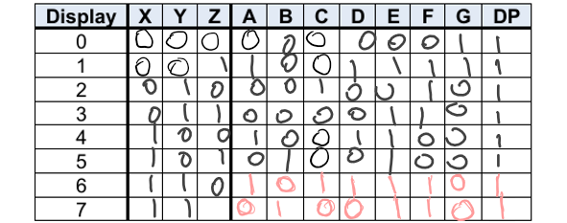
Final Equations for each LED
A and D are duplicates so I don’t need to create 2 separate logic circuits for them. Also, G is a subsection of A and D so I don’t need to create this logic circuit for G, and I can just use the A&D logic circuit. As there are only 2 inputs allowed for the AND gates, I need 2 AND gates to AND three variables together so in this case I will do X’Y’ first then I will AND the output with Z, this way I can also connect this output.
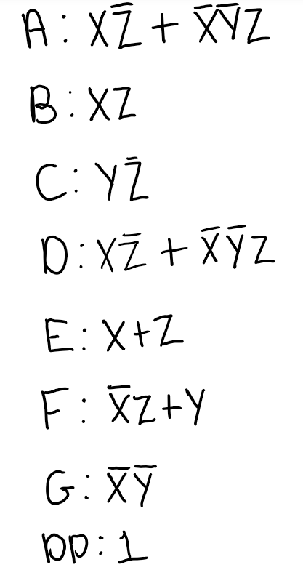
Combinational Logic Block Verification
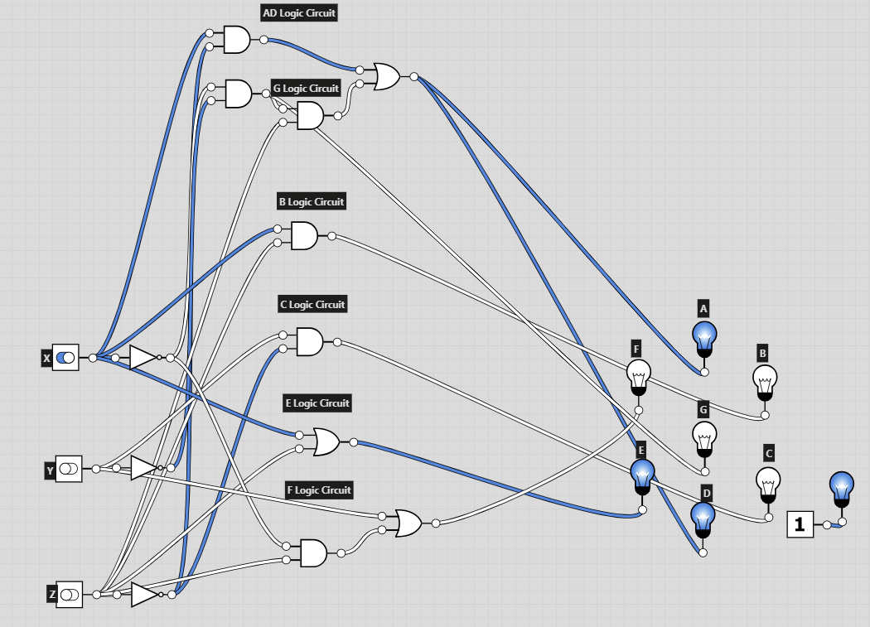
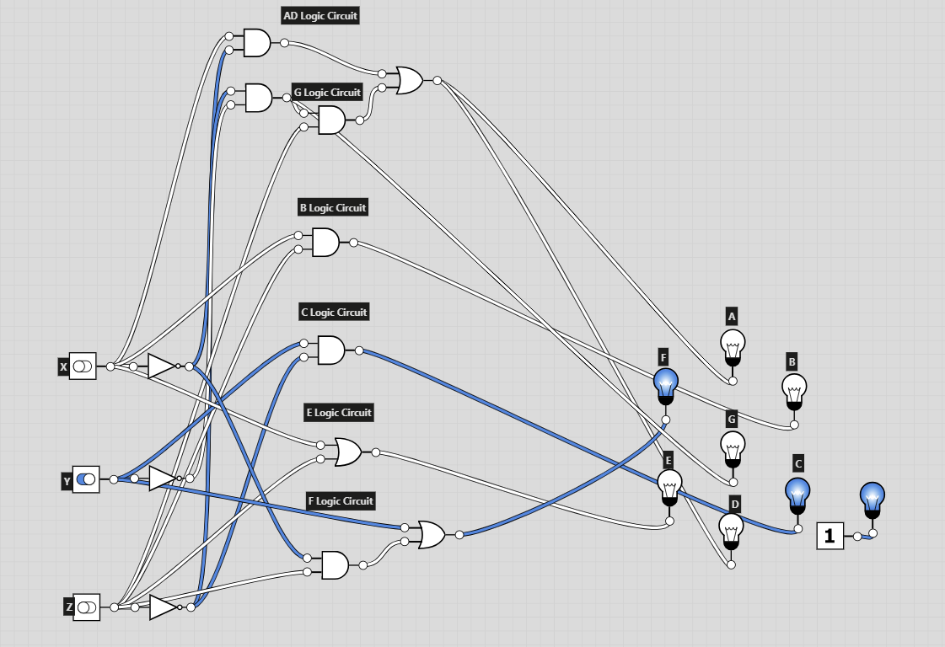
All the numbers were correctly outputted when I created the final logic circuit.
Stripboard PCD design
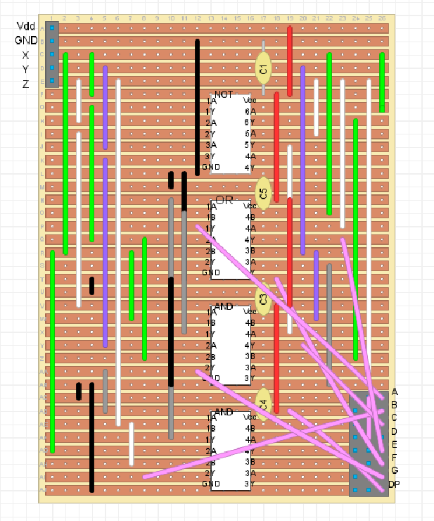
Describe good stuff and bad stuff in tech report

18/11/2025
Constructing Logic Circuit
I soldered on all the components and copied straight from my strip board layout. The layout made the soldering process very easy as I used the same wire colours.
Finished PCB:
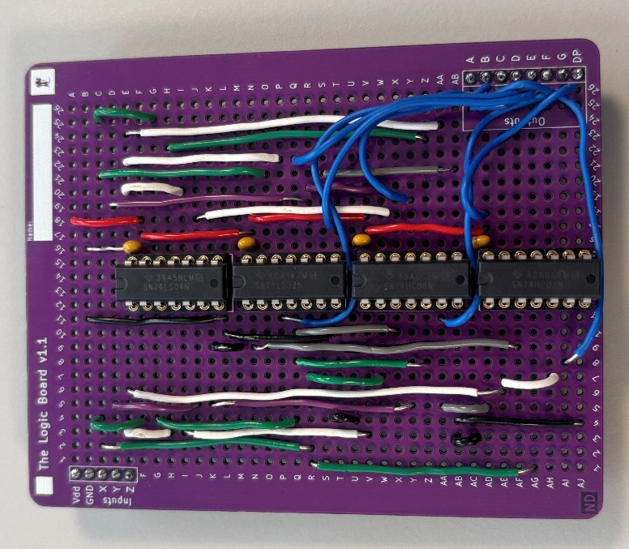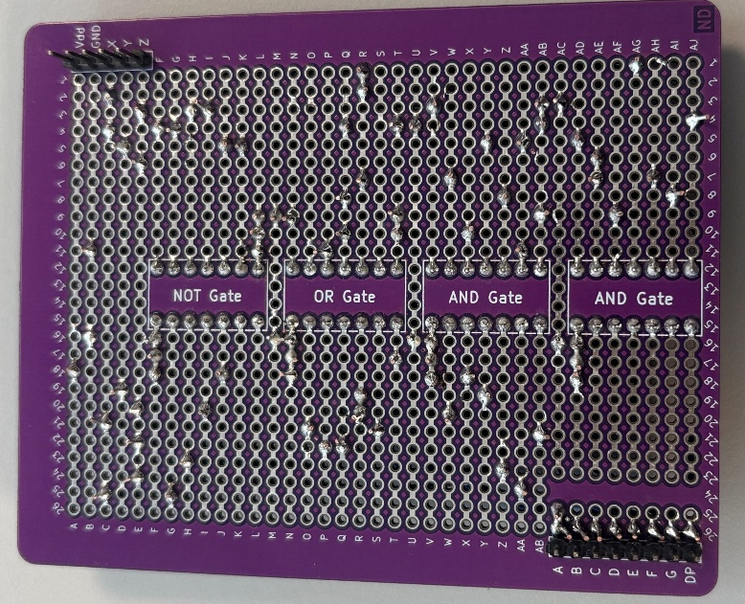

Testing Logic circuit
When I tested this configuration there was an error with A and D. I knew this problem could not be with the X’Y’ part of the circuit as this is used by G and G was working fine. When I compared my physical pcb with the layout I created one of the wires connecting an output to be used in an OR gate was connected to the wrong hole. Indicated by the picture below. I desoldered this wire and replaced it.
PCB with incorrect wire placement
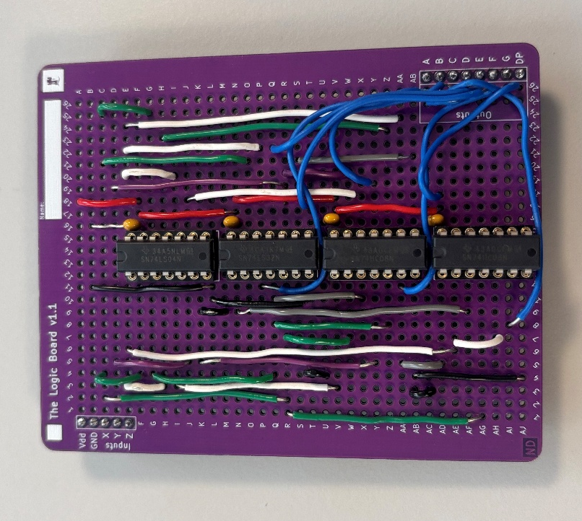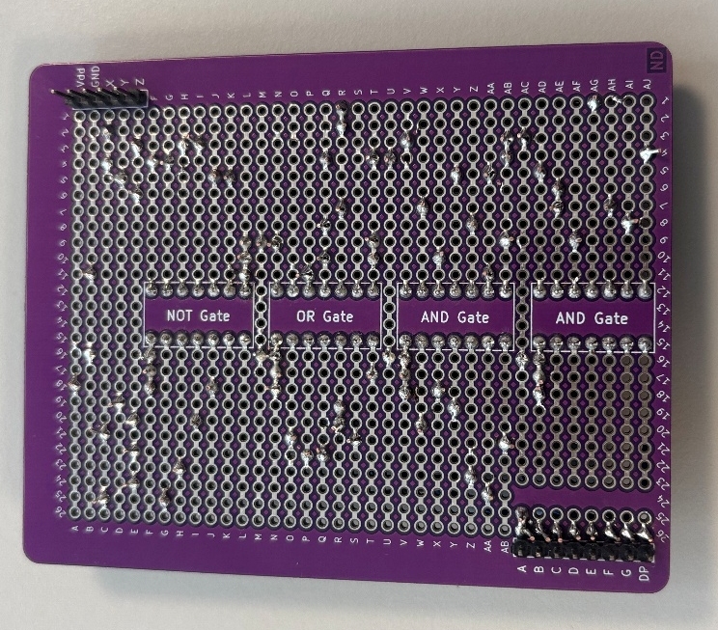
PCB with correct wire placement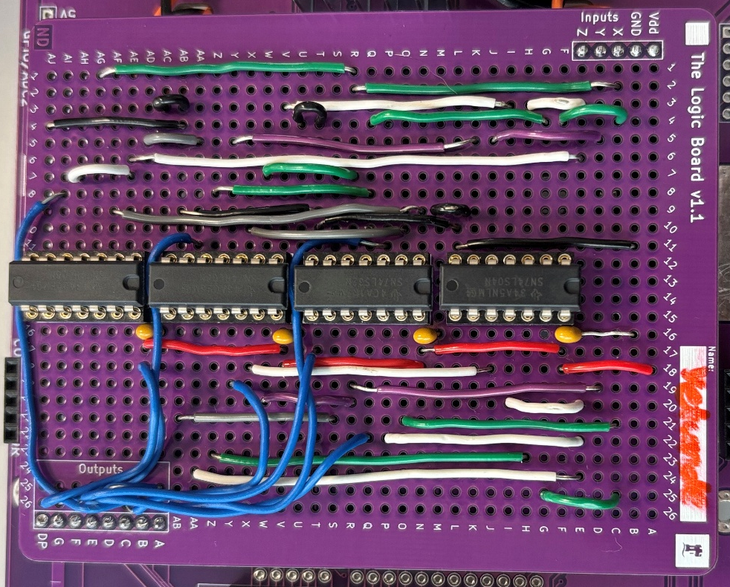
To input 1 into XY or Z I would connect them to the voltage to input 0 I would connect them to ground. Below they are all connected to ground so the input it 000 in binary which should display 0. I set the mustimeter to test voltage and connected it at ground and then each of the outputs. If it read a voltage close to the input voltage (5V) then the output is high/1 if it read a voltage close to 0 then the output is low/0. I repeated this for each number 0-5 and filled out my truth table. Comparing this with my previous truth table I highlighted the outputs that did not match.

Testing set up using a breadboard(left)
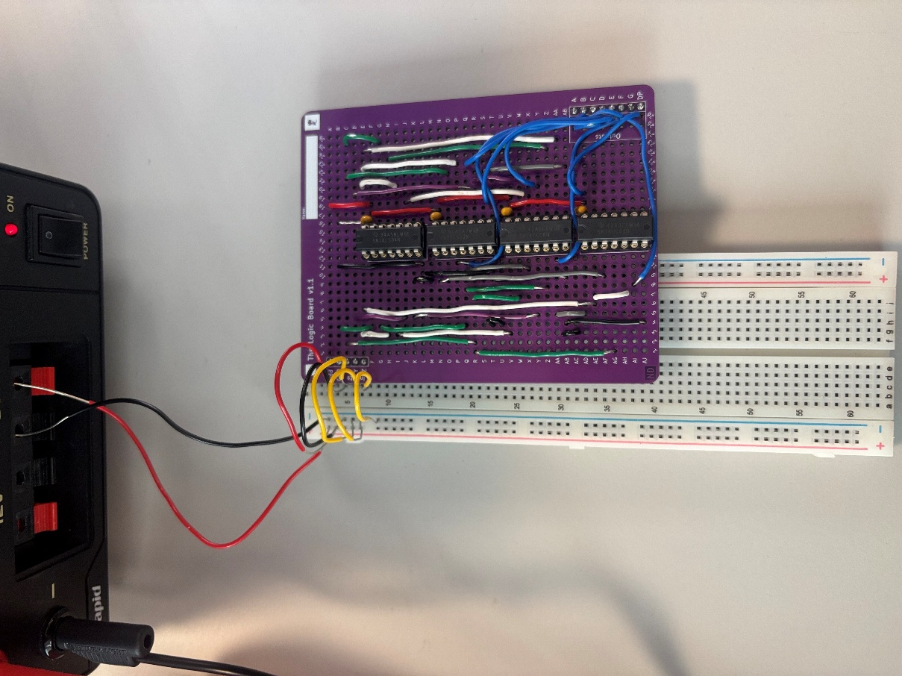
Testing set up using EEEBot
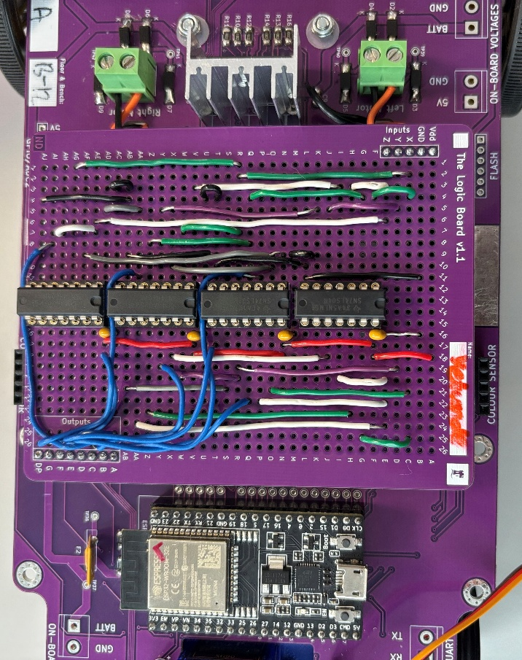
Even with the correct wire placement the test code was still not working and using the breadboard the outputs were still incorrect. One of my AND gates was getting hot when I ran the test code, suggesting a short circuit, after thoroughly looking I could not see any short circuits caused by my soldering. So conducted a continuity test between the ground pin of the AND gate and all the input pins. There was continuity between these which is incorrect. I conducted the test again after taking the AND gate out of the board. This time there was no continuity which is how I knew the AND gate was faulty. I looked at my board again and spotted 2 short circuits. I desoldered these and replaced my AND gate, it is likely that the short circuits damaged the AND gate.
Short circuits spotted:
Truth Table before replacing AND gate and Desoldering
(red numbers are incorrect outputs)
X | Y | Z | A | B | C | D | E | F | G | DP
0 | 0 | 0 | 0 | 0 | 0 | 0 | 0 | 0 | 1 | 1
0 | 0 | 1 | 1 | 1 | 0 | 1 | 1 | 1 | 1 | 1
0 | 1 | 0 | 0 | 0 | 1 | 0 | 0 | 1 | 1 | 1
0 | 1 | 1 | 1 | 1 | 0 | 1 | 0 | 1 | 1 | 1
1 | 0 | 0 | 1 | 0 | 0 | 1 | 1 | 0 | 1 | 1
1 | 0 | 1 | 1 | 0 | 0 | 1 | 1 | 0 | 1 | 1

After replacing the AND gate and desoldering the short circuits the display still would not do the countdown. After analysing what was lighting up and what wasn’t I noticed the countdown was working but LED C would never light up. I conducted a continuity test between all the relevant wires connecting to C. There was continuity. The countdown would work sometimes and not work other times. I removed the display and plugged it back in and then it worked fine.
Truth Table after replacing AND gate and Desoldering and Properly inserting display
X | Y | Z | A | B | C | D | E | F | G | DP
0 | 0 | 0 | 0 | 0 | 0 | 0 | 0 | 0 | 1 | 1
0 | 0 | 1 | 1 | 0 | 0 | 1 | 1 | 1 | 1 | 1
0 | 1 | 0 | 0 | 0 | 1 | 0 | 0 | 1 | 0 | 1
0 | 1 | 1 | 0 | 0 | 0 | 0 | 1 | 1 | 0 | 1
1 | 0 | 0 | 1 | 0 | 0 | 1 | 1 | 0 | 0 | 1
1 | 0 | 1 | 0 | 1 | 0 | 0 | 1 | 0 | 0 | 1



